**“GENERATING UNIT IMPULSE AND UNIT STEP SEQUENCES” LAB # 07**



**Spring 2023**

**CSE301L Signals & Systems Lab**

Submitted by:

***Aimal Khan(21PWCSE1996)***

Class Section: **A**

“On my honor, as student of University of Engineering and Technology, I have neither given nor received unauthorized assistance on this academic work.”

Student Signature:

Submitted to:

**Engr. Durr-e-Nayab**

**Department of Computer Systems Engineering University of Engineering and Technology, Peshawar**

|  |  |  |  |  |  |
| --- | --- | --- | --- | --- | --- |
| **Criteria & Point Assigned** | **Outstanding (5-4)** | **Acceptable (4-3)** | **Considerable (3-2)** | **Below Expectations**  **(2-1)** | **Score** |
| **1. Attendance and Attentiveness in Lab** (PLO10) | Attended in proper Time and  attention in Lab | Attended in proper  Time but not attentive in Lab | Attended late but attentive in Lab | Attended late not attentive in Lab | 5 |
| **2. Capability of writing Program/ Algorithm/Drawi ng Flow Chart** (PLO1, PLO2, PLO3, PLO5) | Right attempt/ no errors and well formatted | Right attempt/ no errors but not well formatted | Right attempt/ minor errors and not well formatted | Wrong attempt | 5 |
| **3. Target**  **Achievement/ Results/Outputs in Lab** (PLO9) | 100% target has been completed and well formatted. | 75% target has been completed and well formatted. | 50% target has Been completed but not well formatted. | None of the outputs are correct | 4 |
| **4. Overall**  **Knowledge**  (PLO10) | Demonstrates excellent knowledge of lab | Demonstrates good knowledge of lab | Has a partial idea about the Lab and procedure followed | Has a poor idea about the Lab and  procedure followed | 4 |
| **5. Attention to Lab Report** (PLO4) | Submission of Lab Report in Proper Time i.e. in the next day of lab., with proper  documentation. | Submission of Lab Report in proper time but not with proper documentation. | Late Submission with proper documentation. | Late Submission Very poor documentation | 9 |

**Instructor: Dr. Durr-e-Nayab**

Signature:

**Lab Objectives:**

**Objectives of this lab are as follows:**

* **Generating unit impulse and unit step sequences.**
* **Basic signal operations.**

**Task # 1:**

**Using one’s function, plot the signum sequence over interval ‐10≤n≤10. It can be defined as:**



**Problem Analysis:**

**Use ones and zeros functions to obtain the given signal. Code:**

clc

clear all

n = -10:10;

x1=[-ones(1,10) zeros(1,1) ones(1,10)]; stem(n,x1,'filled');

axis([-10 10 -2 2]);

**Output:**

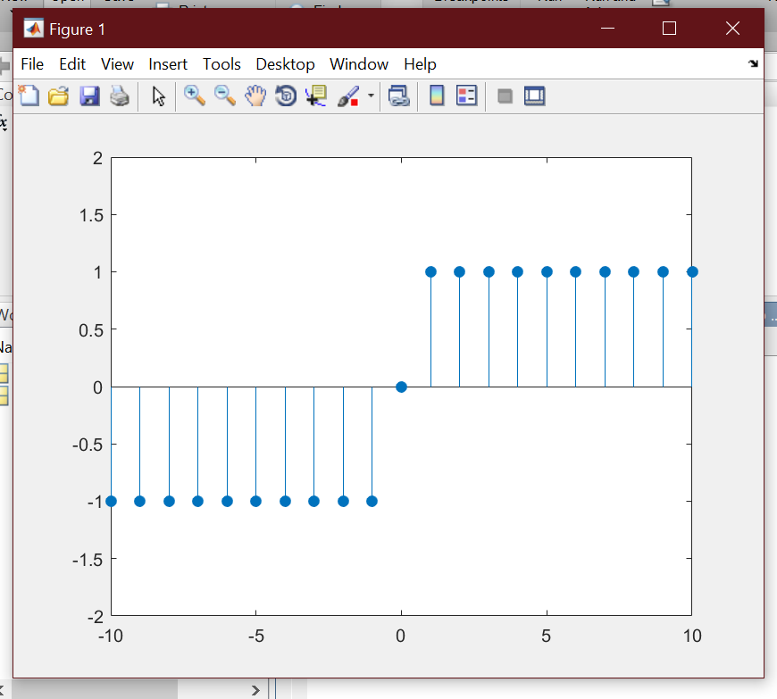

**Task # 2:**

**Prove the following:**



**Problem Analysis:**

**To prove the given equation first generate a unit step signal and then subtract a shifted unit step signal from it.**

**Code:**

clc

clear all n=-10:10;

u0=[zeros(1,10) ones(1,11)]; subplot(3,1,1);

stem(n,u0,'filled');

axis([-10 10 -1 1]);

title('u[n]');

u1=[zeros(1,11) ones(1,10)]; subplot(3,1,2);

stem(n,u1,'filled');

axis([-10 10 -1 1]);

title('u[n-1]'); u=u0-u1; subplot(3,1,3);

stem(n,u,'filled');

axis([-10 10 -1 1]);

title('Result');

**Output:**

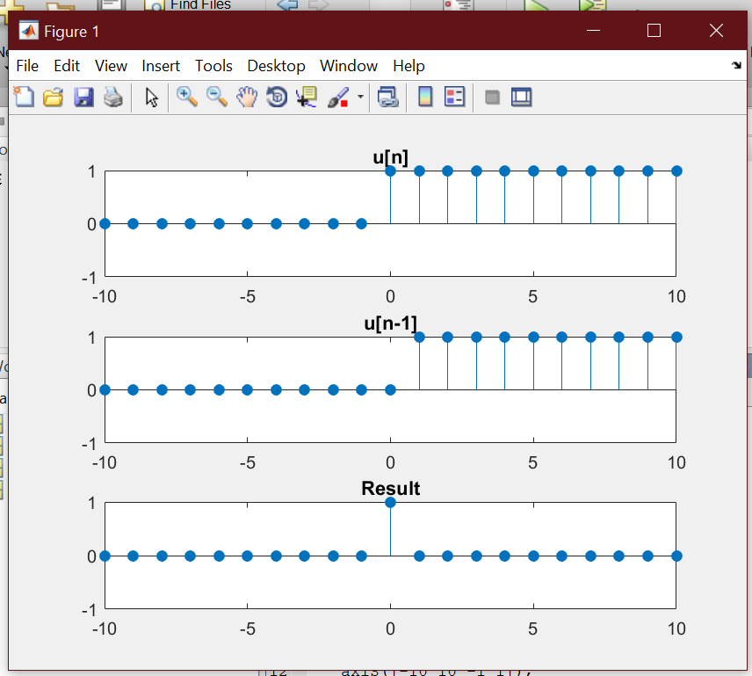

**Task # 3:**

**Delay the original signal given in above example by 1 sec. Plot both the delayed & original signal on the same figure.**

**Problem Analysis:**

**To delay the signal by one unit, add one to the x-axis of the signal.**

**Code:**

clc

clear all

n=0:0.05:4;

x=sin(2*pi*1*n); subplot(2,1,1); plot(n,x,'linewidth',2); title('Original Signal'); xlabel('Time'); ylabel('Signal Amplitude'); axis([-3 4 -1 1]);

grid; subplot(2,1,2);

plot(n+1,x,'linewidth',2); title('Delayed signal'); xlabel('Time'); ylabel('Signal Amplitude'); axis([-3 4 -1 1]);

grid;

**Output:**

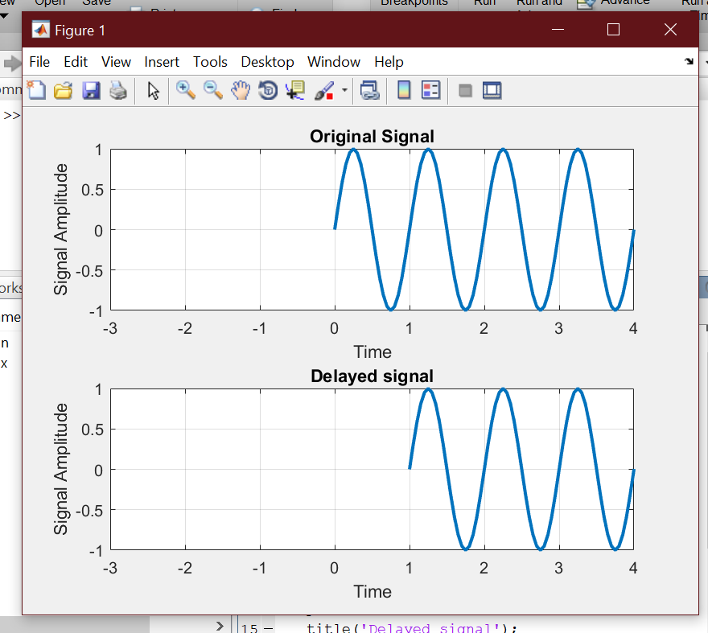

**Task # 4:**

**Flip the following signal:**



**Plot the original signal as well as the flipped one in the same figure.**

**Problem Analysis:**

**To flip the given signal, multiply the x-axis of the signal to by minus.**

**Code:**

clc

clear all

n=-1:1/2000:1;

x1=5*exp(5*n*pi/4); subplot(2,1,1);

plot(n,x1, 'g', 'linewidth',2); axis([-1 1 -5 5]);

xlabel('time'); ylabel('signal amplitude'); title('Original sine wave'); grid;

subplot(2,1,2);

plot(-n,x1, 'r', 'linewidth',2); axis([-1 1 -5 5]);

xlabel('time'); ylabel('signal amplitude'); title('Flipped sine wave'); grid;

**Output:**

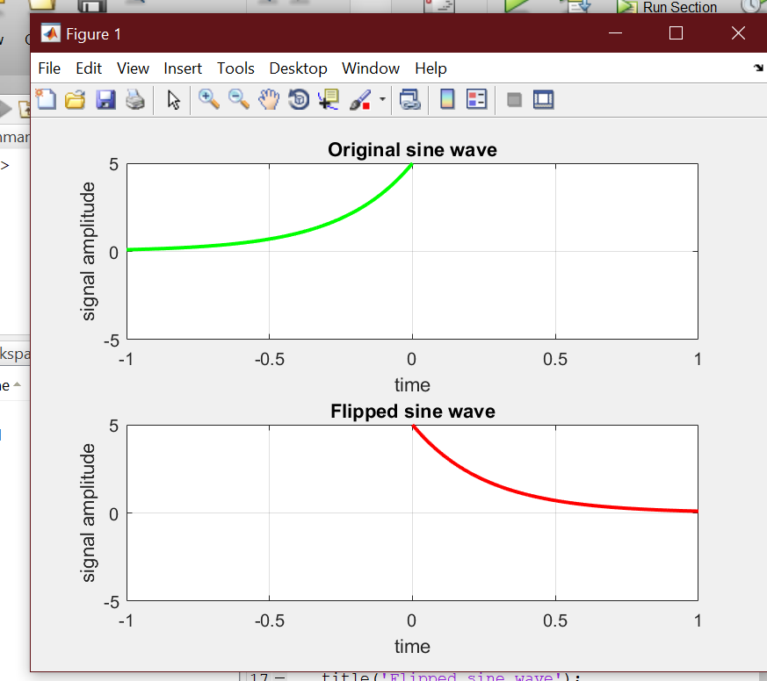

**Task # 5:**

**Flip the following signal:**

**x[n]= 2δ[n]+ 5δ[n‐1] + 8δ[n‐2] + 4δ[n‐3] + 3δ[n‐4]**

**Plot the original signal as well as the flipped one in the same figure.**

**Problem Analysis:**

**Generate the signal as described above and then flip it.**

**Code:**

clc

clear all

|  |  |  |
| --- | --- | --- |
| n=-10:10; |  | |
| x=[zeros(1,10) | ones(1,1) | zeros(1,10)]; |
| x0=2*x; |  |  |
| x=[zeros(1,11) | ones(1,1) | zeros(1,9)]; |
| x1=5*x; |  |  |
| x=[zeros(1,12) | ones(1,1) | zeros(1,8)]; |
| x2=8*x; |  |  |
| x=[zeros(1,13) | ones(1,1) | zeros(1,7)]; |
| x3=4*x; |  |  |
| x=[zeros(1,14) | ones(1,1) | zeros(1,6)]; |
| x4=3*x; |  |  |

xr=x0+x1+x2+x3+x4; subplot(2,1,1);

stem(n,xr,'filled');

axis([-10 10 -10 10]);

title('Original Signal'); subplot(2,1,2);

stem(-n,xr,'filled');

axis([-10 10 -10 10]);

title('Flipped Signal');

**Output:**

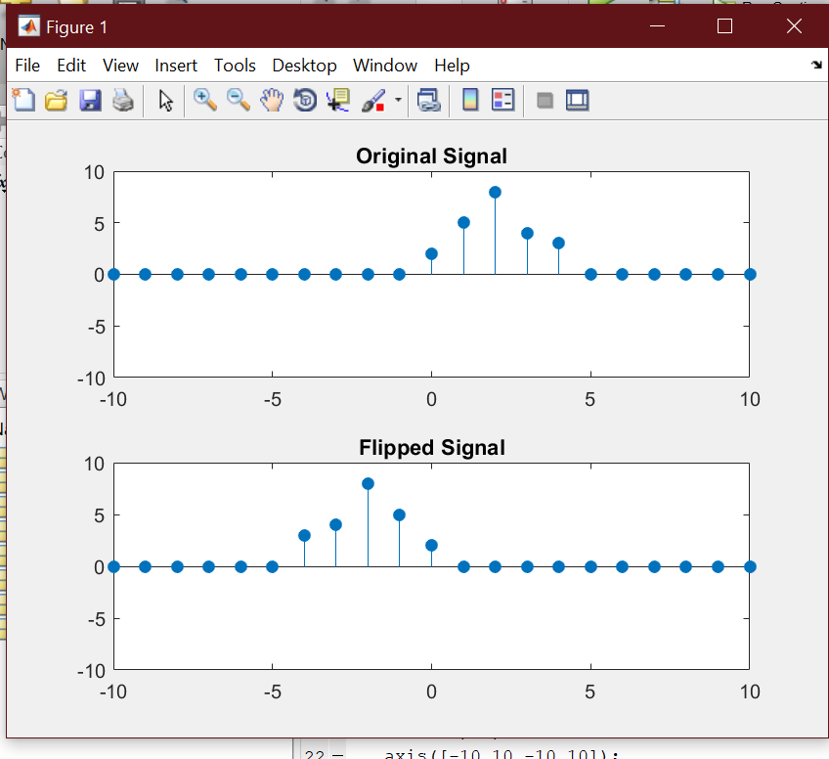

**Task # 6:**

**Scale the continuous‐time sinusoid used in the signal shifting example by a factor of 2.**

**Problem Analysis:**

**To scale the amplitude of the signal, multiply the y-axis of the signal by the given factor.**

**Code:**

clc

clear all n=0:0.002:4;

x=sin(2*pi*1*n); subplot(2,1,1); plot(n,x,'linewidth',2); title('Original Signal'); xlabel('Time'); ylabel('Signal Amplitude'); axis([-3 4 -4 4]);

grid; subplot(2,1,2); S=2;

plot(n,S*x,'linewidth',2); title('Scaled Amplitude Signal'); xlabel('Time');

ylabel('Signal Amplitude'); axis([-3 4 -4 4]);

grid;

**Output:**

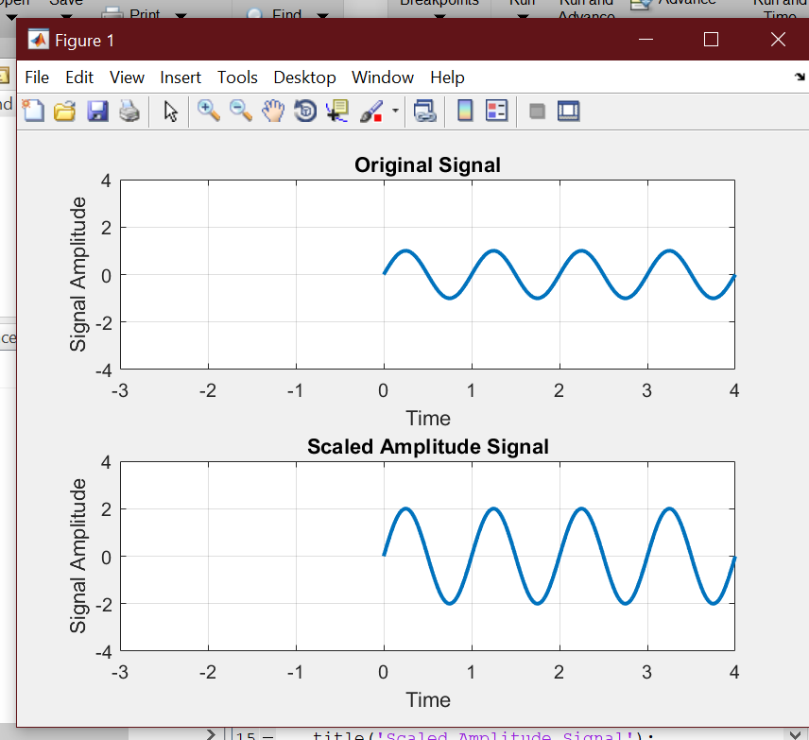

**Task # 7:**

**Interpolate (up‐sample) the signal by a factor of 2.**

**Problem Analysis:**

**To interpolate the given signal use interp command.**

**Code:**

clc

clear all

n=-2:1/1000:2;

x1=sin(2*pi*2*n); x2=interp(x1,2); subplot(2,1,1); plot(x1);

title('Original signal'); xlabel('Sample Number'); ylabel('Signal Amplitude'); axis([0 4000 -1 1]);

grid; subplot(2,1,2); plot(x2);

title('Interpolated Signal'); xlabel('Sample Number'); ylabel('Signal Amplitude'); axis([0 2000 -1 1]);

grid;

**Output:**



